Trust Me

digital Youth work session one
60-minute session to facilitate in a digital youth work setting.
To facilitate this Action pack digitally, we have prepared a PowerPoint file, which you can download below.
The session also makes use of the Zoom “Annotate” feature, which allows participants to add text and drawings to what is being shared on the screen. As host, you are able to remove any inappropriate contributions immediately.
To enable this feature:
- Visit the Zoom website
- Click on “Settings”
- Under “Annotate”, ensure this box is ticked: “Allow host and participants to use annotation tools to add information to shared screens.”

Session 1
This session will provide an opportunity to reflect on the Trust Me film through discussion and teamwork. You will play an “Agree/Disagree” game to explore common misconceptions about gambling, examine the film characters’ emotions and choices by looking at film scenes, and challenge your young people to collaboratively assess how risky certain gambling behaviours are.

Gambling a-z
10 minutes.
Learning outcomes: To serve as an icebreaker and start conversations about gambling.
The first slide of the PowerPoint displays the letters A to Z. Using the Zoom annotate feature, ask the young people to take turns coming up with a gambling-related word starting with each letter of the alphabet, and adding it to the slide. If a young person is stuck and cannot think of a word, other group members can help.

what’s your opinion?
20 minutes.
Learning outcomes: To repeat learning points from the film and video session, exploring common misconceptions about gambling and providing additional opportunities for discussion.
The following 11 slides contain various gambling-related statements. Using the Zoom “Reaction” feature, ask young people to react to each statement by clicking on the “Thumbs Up”/”Crying” emojis. After all participants shared an emoji on their position with the statement, pick someone to share why they chose that emoji.
- Jack was unlucky.
- You have to lose a lot of money to experience a problem with your gambling.
- In Trust Me, Jack was the only one harmed by his gambling.
- Keeping gambling a secret only creates more problems.
- People have to gamble for years to develop an addiction.
- Gambling on a free internet site is harmless because no money is used.
- Gambling is a quick way of making lots of money if you know what you’re doing.
- Gambling on your phone is more addictive than gambling in a betting shop.
- People who win the lottery are happy for the rest of their lives.

Picture round
30 minutes.
Learning outcomes: To explore the various aspects of gambling introduced by the film, and discuss ways of practicing safer gambling.
The next 12 slides contain pictures of various scenes from the Trust Me film. Give each participant a turn answering the below questions to one of the pictures. After a participant has shared their thoughts on their picture, ask the rest of the group to share their thoughts.
For each picture, answer the following questions:
- What happens in this scene?*
- What could the character(s) in the scene be feeling right now?
- What advice would you give the character(s) in the picture?

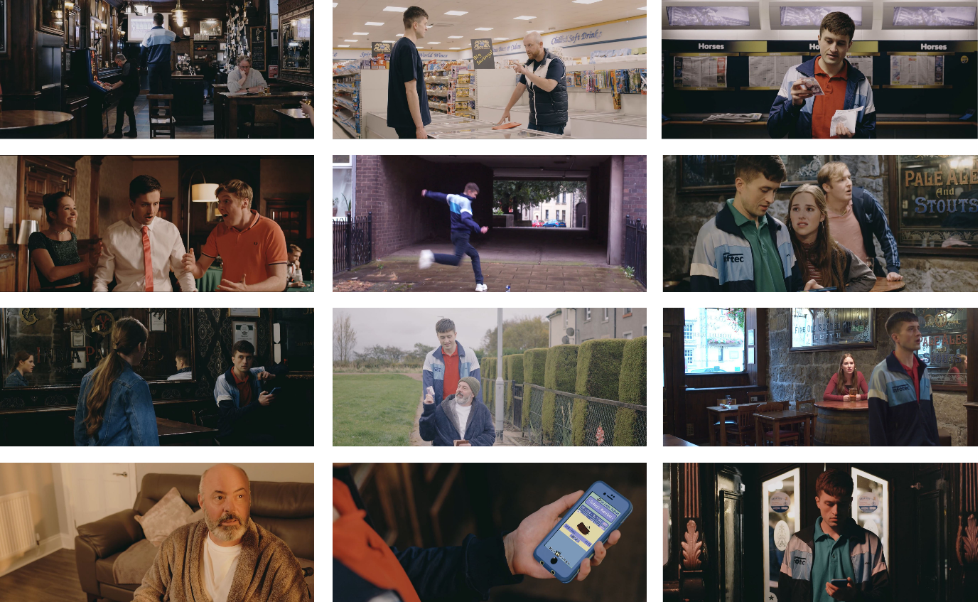
*A synopsis of each scene is provided below:
1. The start/end of the film. Jack has taken money from his dad without his consent to bet on a horse race, hoping he will win back his and his friends’ holiday money.
2. Jack asks his boss for help getting a loan from his brother, a loan shark. Instead, his boss gives him a tip to bet on a horse race. In return, Jack will “owe him”.
3. Jack has entered a ‘bookies’ for the first time, about to gamble away all of his and his friends’ holiday money.
4. Against all odds, Jack won his first bet on roulette at the casino.
5. Jack kicks a can on the floor and is reminded of how much he loved playing football and misses it.
6. Jack bets on a football game using a gambling app for the first time. He wins, and is convinced he has the nack.
7. Becky finds Jack sitting alone in the corner of the pub, betting on his gambling app. He has lost a lot of money.
8. Jack’s dad gives Jack his credit card, after Jack asks him if he could borrow money for the deposit of a new flat. In truth, Jack is planning on using the money to gamble on a horse race.
9. Jack has bet on a horse race and is awaiting the outcome. Becky confronts Jack – she believes he has developed a problem with his gambling and should seek help.
10. Jack’s dad has just asked Jack to buy him a lottery ticket, and is imagining the life he would lead if he was to win.
11. After trying to control and cut down his gambling, Jack receives a pop-up notification on his phone with a free £5 credit towards a bet, drawing him back into gambling.
12. Jack has just gambled away his week’s wages in 3 hours by betting online.

Gambling behaviour ladder
20 minutes.
Learning outcomes: To consider the spectrum of risk associated with gambling, and understand what constitutes harm.
The next slide contains 5 scenarios labeled A) to E). Read out the scenarios. Then, ask participants to rank these scenarios on a piece of paper from least (1) to most (5) risky. Ask them to consider the frequency, stake size and motivation behind each character’s gambling. Afterwards, ask everyone to share where they placed each scenario and why.
- Ryan wins £20 at the quiz machine, so he goes back with more money this time, hoping to win the Jackpot on the fruit machine.
- Jack stole money from his dad to bet on a horse race, hoping he will win back the money he stole from his friends.
- Becky’s gran puts £100 on the Grand National every year as a fun way of spending time with her family.
- Becky and Jack flip a coin to establish who has to mop the floor.
- Jack’s dad spends £2 a week on the lottery, even though he is struggling to pay his bills.

Support available
10 minutes.
Learning outcomes: To wind down the session by talking about the avenues of support that are available to someone experiencing gambling harm, as well as to those around him.
Ask participants to think of avenues of support that are available to someone who is experiencing gambling harm, due to their own or someone else’s gambling. Gather answers using the Zoom “Whiteboard” feature.
Examples include: speaking to a friend, parent, teacher or youth worker; visiting website for information (GambleAware.org); calling a helpline or using chat service; self-excluding yourself from betting shops; using blocking software for devices.

