Trust Me

Youth Work session one
90-minute session to facilitate in a face-to-face youth work setting.

Session 1
This session will provide an opportunity to reflect on the Trust Me film through discussion and teamwork. You will play an “Agree/Disagree” game to explore common misconceptions about gambling, examine the film characters’ emotions and choices by looking at film scenes, and challenge your young people to collaboratively assess how risky certain gambling behaviours are.

Gambling ABC
10 minutes.
Learning outcomes: To serve as an icebreaker and start conversations about gambling.
On a whiteboard or piece of paper, ask a young person to write the letters A to Z in a vertical line. Then, take turns coming up with a gambling-related word starting with each letter of the alphabet. If a young person is stuck and cannot think of a word, other group members can help.

Agree/Disagree
20 minutes.
Learning outcomes: To repeat learning points from the film and video session, exploring common misconceptions about gambling and providing additional opportunities for discussion.
Mark opposite ends of the room/area by placing an Agree sign on one end, and a Disagree sign on the other. Now, read out the statements (below) and ask the young people to position themselves in the room according to their opinion on the statement. Participants can also place themselves in the middle if they are undecided, or somewhat agree/disagree by stepping closer to the middle line. After all participants decided on their position, ask them to share what they considered and why they are standing where they are.
- Gambling is a form of entertainment.
- The House Edge means there is a 50/50 chance of winning the game.
- Jack was unlucky.
- You have to lose a lot of money to experience a problem with your gambling.
- In Trust Me, Jack was the only one harmed by his gambling.
- Keeping gambling a secret only creates more problems.
- People have to gamble for years to develop an addiction.
- Gambling on a free internet site is harmless because no money is used.
- Gambling is a quick way of making lots of money if you know what you’re doing.
- Gambling on your phone is more addictive than gambling in a betting shop.
- People who win the lottery are happy for the rest of their lives.
Picture round
30 minutes.
Learning outcomes: To explore the various aspects of gambling introduced by the film, and discuss ways of practicing safer gambling.
Print out the pictures below and place them in a stack on the table (larger pictures in appendices). Now, ask each participant to take a turn answering the below questions to one of the pictures. After a participant has shared their thoughts on their picture, ask the rest of the group to share their thoughts.
For each picture, answer the following questions:
- What happens in this scene?*
- What could the character(s) in the scene be feeling right now?
- What advice would you give the character(s) in the picture?
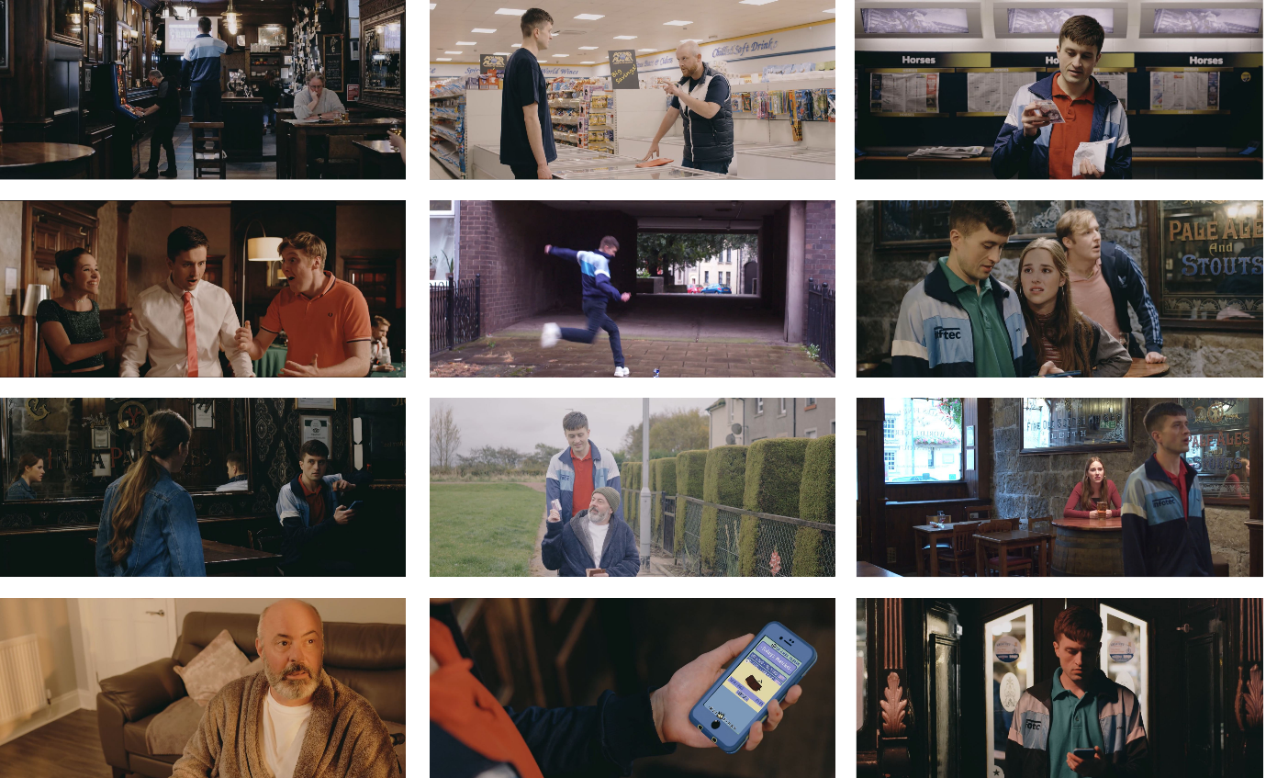
*A synopsis of each scene is provided below:
1. The start/end of the film. Jack has taken money from his dad without his consent to bet on a horse race, hoping he will win back his and his friends’ holiday money.
2. Jack asks his boss for help getting a loan from his brother, a loan shark. Instead, his boss gives him a tip to bet on a horse race. In return, Jack will “owe him”.
3. Jack has entered a bookies for the first time, about to gamble away all of his and his friends’ holiday money.
4. Jack has placed a bet on the roulette and won big.
5. Jack kicks a can on the floor and is reminded of how much he loved playing football.
6. Jack bets on a football game using a gambling app for the first time. He wins, and is convinced he has the nack.
7. Becky finds Jack sitting alone in the corner of the pub, betting on his gambling app. He has lost a lot of money.
8. Jack’s dad gives Jack his credit card, after Jack asks him if he could borrow money for the deposit of a new flat. In truth, Jack is planning on using the money to gamble on a horse race.
9. Jack has bet on a horse race and is awaiting the outcome. Becky confronts Jack – she believes he has developed a problem with his gambling and should seek help.
10. Jack’s dad has just asked Jack to buy him a lottery ticket, and is imagining the life he would lead if he was to win.
11. Jack has received a pop-up notification on his phone with a free £5 credit towards a bet, drawing him back into gambling.
12. Jack has just gambled away his week’s wages in 3 hours by betting online.

Gambling behaviour ladder
20 minutes.
Learning outcomes: To consider the spectrum of risk associated with gambling, and understand what constitutes harm.
Split the group into teams of 3 or 4. Print out the table below for each team, and cut out the scenarios individually. In their groups, ask the young people to rank these scenarios from least (1) to most (5) risky. Ask them to consider the frequency, stake size and motivation behind each character’s gambling. Afterwards, ask each group to share where they placed each scenario and why.
Remember to emphasise that all gambling involves an element of risk; however, some gambling activities and behaviors may be riskier than others.

Ryan wins £20 at the quiz machine, so he goes back with more money this time, hoping to win the Jackpot on the fruit machine.
Jack stole money from his dad to bet on a horse race, hoping he will win back the money he stole from his friends.
Becky’s gran puts £20 on the Grand National every year as a fun way of spending time with her family.
Becky and Jack flip a coin to establish who has to mop the floor.
Jack’s dad spends £2 a week on the lottery, even though he is struggling to pay his bills.

Support available
10 minutes.
Learning outcomes: To wind down the session by talking about the avenues of support that are available to someone experiencing gambling harm, as well as to those around him.
Ask participants to think of avenues of support that are available to someone who is experiencing gambling harm, due to their own gambling or someone else’s gambling. Gather answers on a whiteboard, or using post-it notes.
Examples include: speaking to a friend, parent, teacher or youth worker; visiting website for information (BeGambleAware.org or BigDeal.org.uk); calling a helpline or using chat service; self-excluding yourself from betting shops; using blocking software for devices.
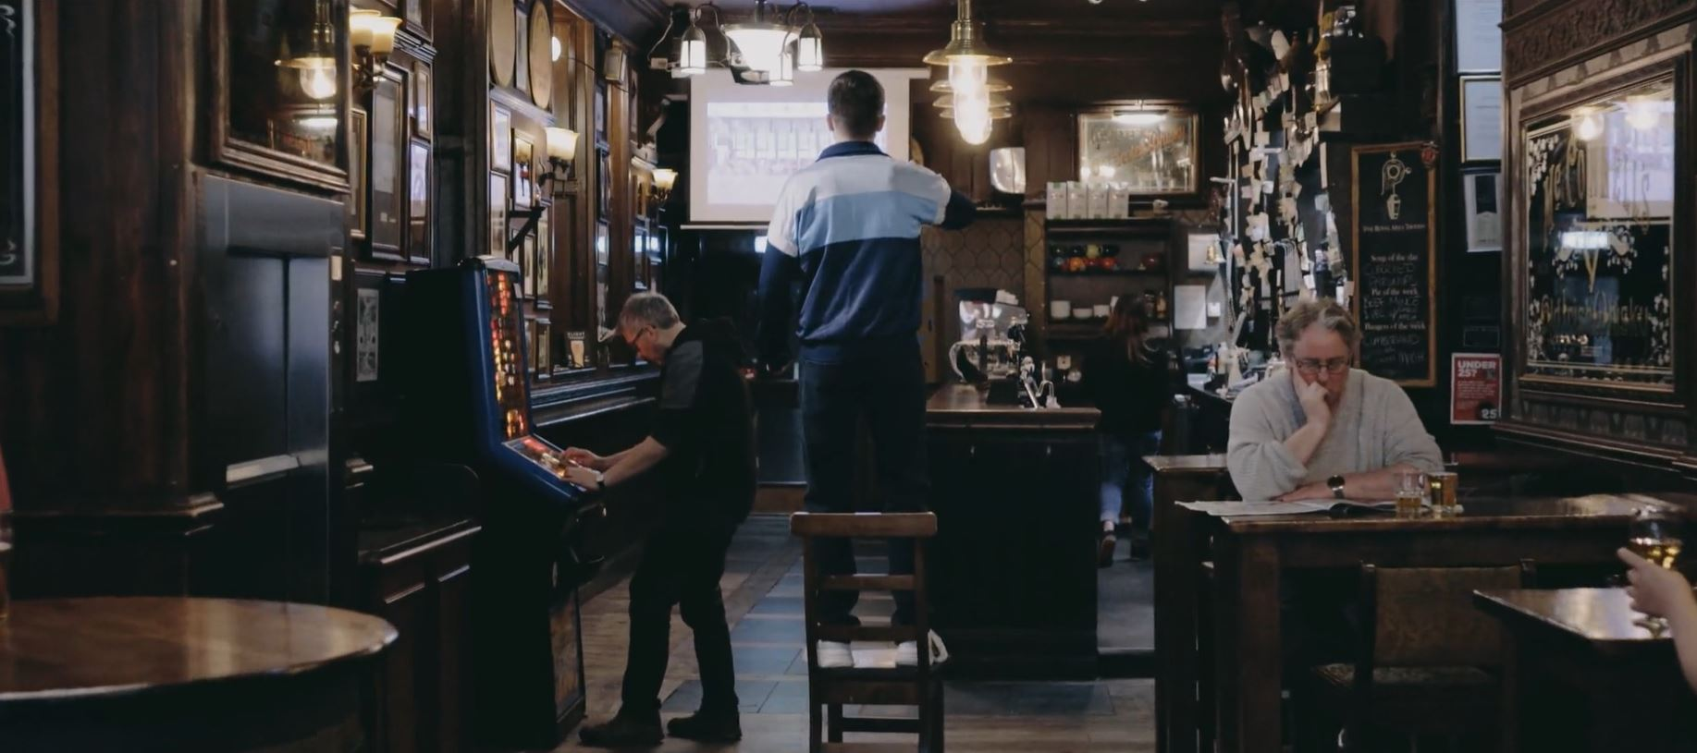
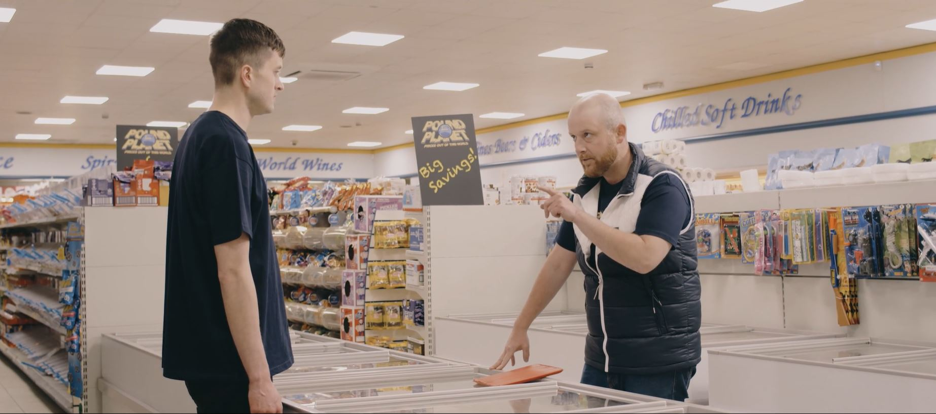
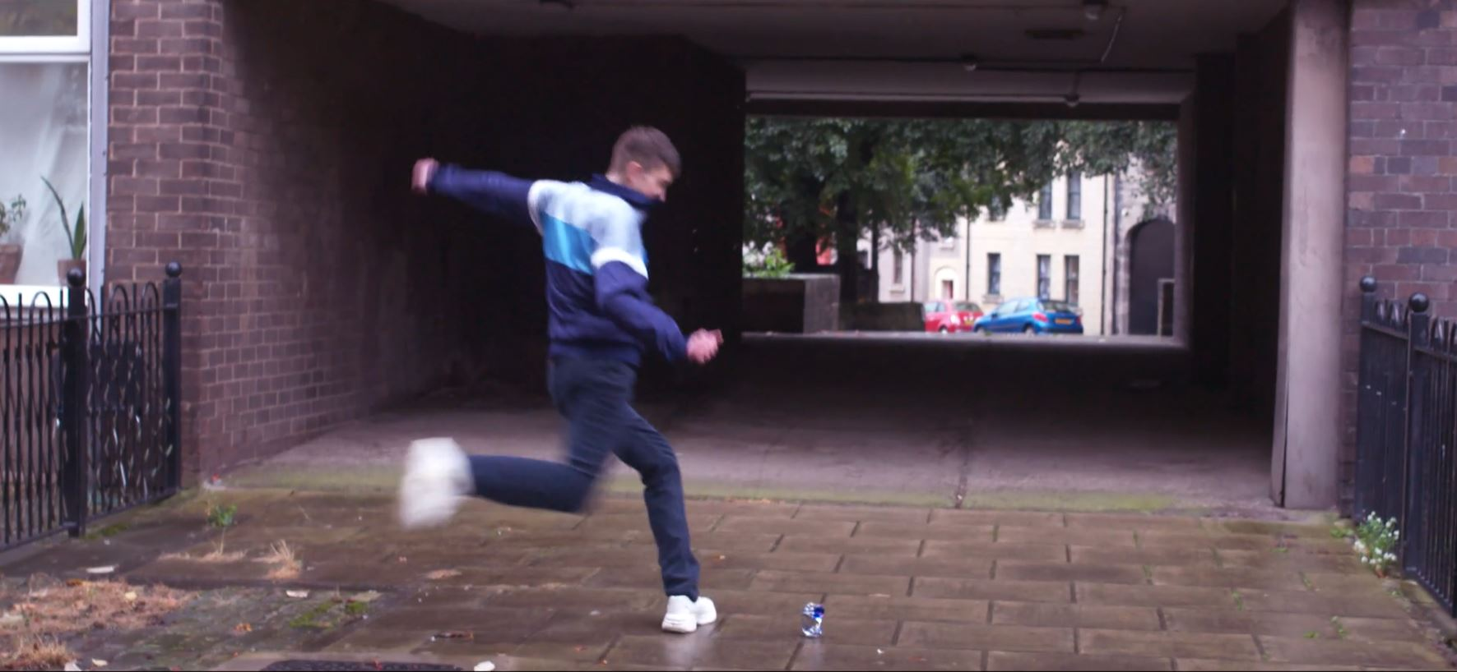
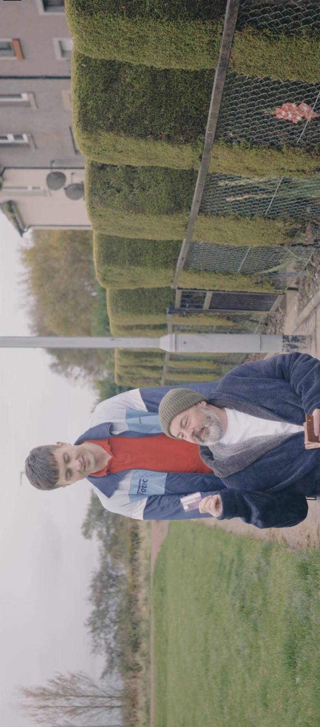
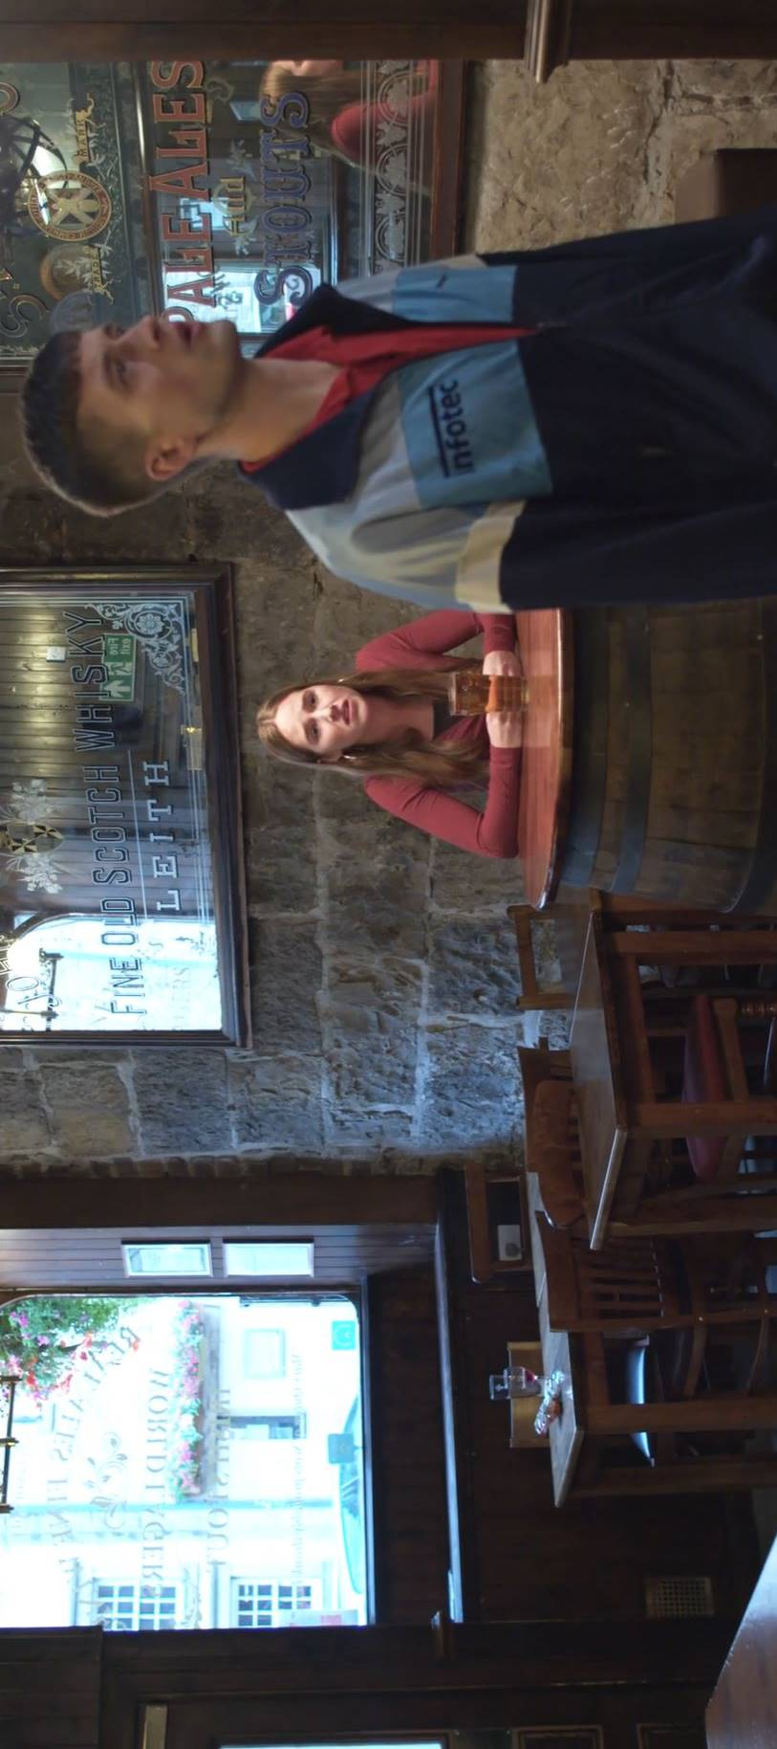
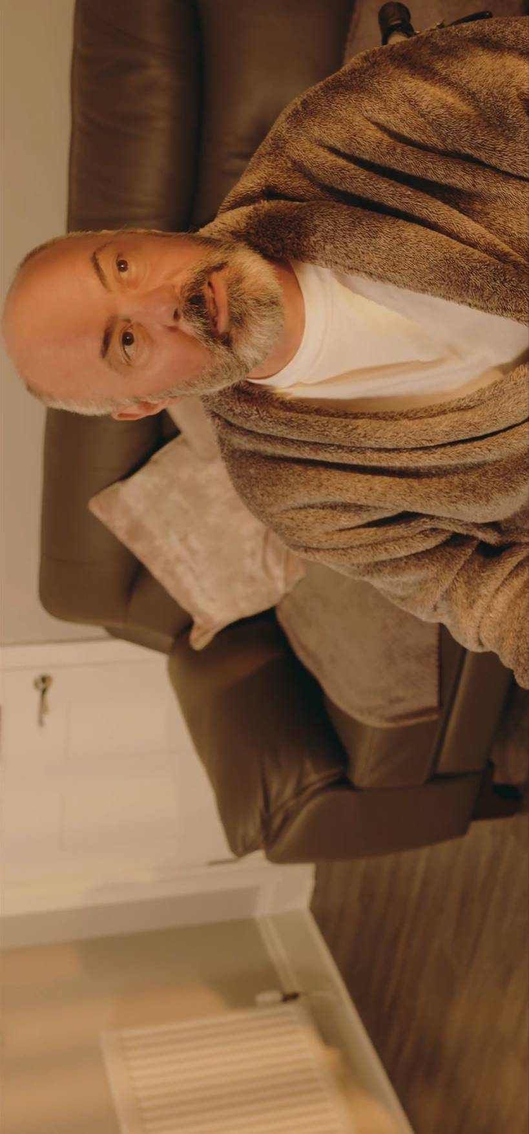
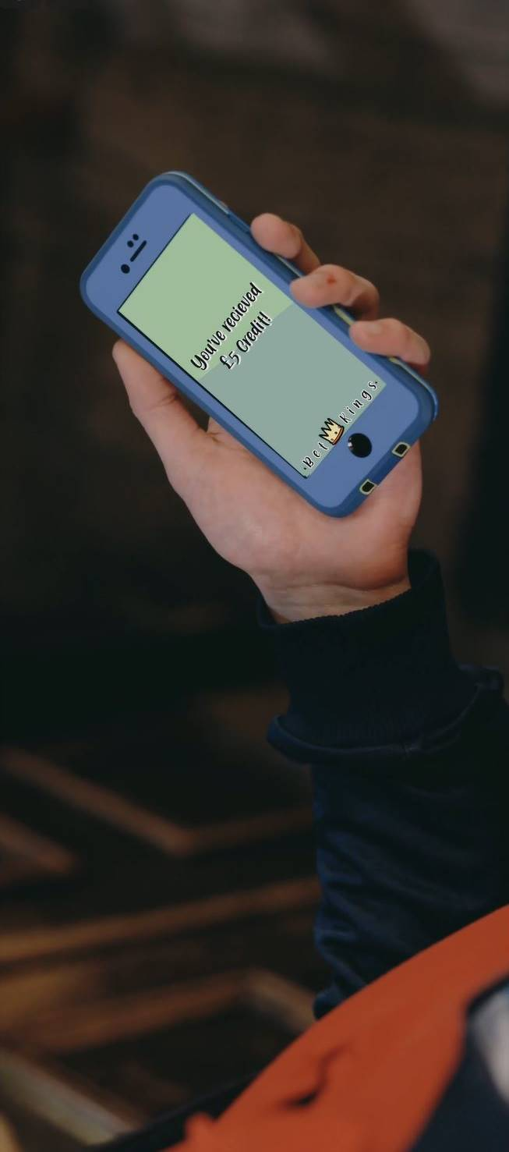
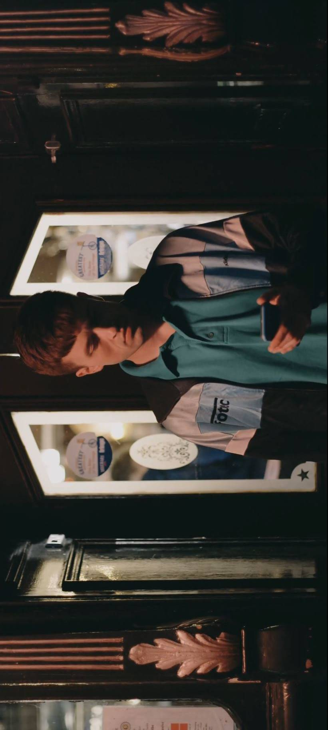

Session 2
In this session, participants will explore Jack’s situation more deeply, unpacking why he gambles and what could help him stop. The group will examine how gambling relates to our own lives, develop an Empathy Map to better understand Jack’s situation, and use their creativity to finish the story. The group will then work together to develop a poster on gambling harm reduction.

Last ONE Standing
10 minutes.
Learning outcomes: To repeat learning from previous sessions, and to make connections with how gambling may relate to our own lives and circumstances.
Ask the group to stand up in a circle. As the facilitator, you will read out each statement (below), and ask participants to sit down if that statement doesn’t apply to them. The following statement will then be asked only to those still standing. For statements regarding their knowledge, ask some of those standing up to share.
Stay standing, if…
  - You can name 3 examples of gambling games that came up in Trust Me.
  - You think that there are young people in your school who gamble.
  - You have watched TV in the last 3 days.
  - You have seen a gambling advert in the last 3 days (on TV/on a billboard/online/…).
  - There is somewhere close to you where you can gamble.
  - You can name one harmful effect of gambling.
  - Know what a loot box is.
  - You have ever played a video game/app game that had loot boxes in it.
  - You have never scratched a scratch card.
  - You know what to do if you or someone you know is experiencing gambling harm.
  - You have ever talked to someone about the risks or harms of gambling.
  - You remember how much money Jack lost at the bookies.

Jack’s Cycle
20 minutes.
Learning outcomes: To explore in more detail what circumstances, events and choices can lead someone to develop a problem with their gambling, and what can be done to
By the end of the film, Jack is trapped in a cycle as he continues gambling to escape his problems caused by prior gambling. This activity helps explore what led him into this situation, as well as opportunities for breaking this cycle. On a whiteboard/large sheet of paper, draw out Jack’s silhouette, as well as a big circle around it. Participants will add post-it notes to each area in stages (the circle, the silhouette, the area outside the circle) with reflection time in between.
- Using post-it notes, ask the participants to answer the question: What has led Jack to gamble, and to continue gambling? (E.g. he can’t play football, he doesn’t like his job, he stole money from his friends and needs to pay them back, he keeps getting gambling offers on his phone, …)
Ask participants to stick these post-it notes in the circle around Jack.

- Now, using a different colour of post-it note, ask participants to answer this question: What is Jack feeling? What is he not sharing with others? (E.g. he may feel out of control, stuck, depressed, anxious, helpless, guilty for stealing, under pressure for having to make decisions about his future, …)
Ask the participants to add these post-it notes into Jack’s silhouette.

- Now, ask the participants to have a look at all the post-it notes in front of them. The many different aspects to Jack’s situation may make him feel overwhelmed and unable to act. Instead of trying to solve all his problems at once, ask the participants to have a look at some of the individual post-it notes and find examples of things Jack could do to improve this aspect of his situation.
What could Jack do to improve his situation? (E.g. talk to his friends about his feelings, install blocking software, try coaching football, find a job or a hobby he enjoys more, ask for help with managing his finances, …)

How will the story end?
40 minutes.
Learning outcomes: To use creativity to come up with harm reduction strategies.
Split up the group into teams of 3 or 4. Each team is now given 15 minutes to come up with a continuation of the story from the moment Jack is standing on the chair in the pub. Their story should be realistic to the characters, and end in a positive way. It should involve at least 3 characters from the film.
Each group then takes turns telling or acting out their story.
Note: If a group decides to finish the story by having Jack win the race and solve all his problems using the prize money, spend some time reflecting on how this would impact his gambling behavior long-term. How likely is it that Jack will never gamble again? What would happen the next time he was in financial difficulties, was tempted by a notification on his phone, or a football game whose outcome he thought he could predict?

Harm Reduction Poster
20 minutes.
Learning outcomes: To summarise the learning from previous sessions, and to revisit avenues of support.
Depending on group size, split the group or facilitate this activity in one big group.
Design a poster on what advice we can give on:
  - How to reduce the risk of harm when gambling.
  - What to do if you, or someone you know, is experiencing harm from gambling.

Start this process by gathering ideas on a mind map, asking all participants to contribute what should be included in the poster. Then, sort the ideas into headings or “sections” of the poster. You can then split up the group into smaller teams and ask each team to design one section, which can then be assembled to make up the poster.
Ensure that the poster includes the GambleAware website (begambleaware.org) and the National Gambling Treatment Service Hotline (0808 8020 133). It could also include information on blocking software, and on which staff members within your organization the young people can consult about gambling.
Participants may also want to include information about BigDeal.org.uk, a website designed for young people to provide information about gambling and support available.
This poster will be a great resource to hang up in your space, ensuring young people remember the key learnings from the session.

