Trust Me

TEACHER lesson plan one
50-minute lesson plan to consolidate the learning from the Trust Me film
Delivering these lessons following the viewing of the Trust Me Film will enable young people to develop their knowledge about gambling harms and strengthen their capacity to make informed choices.
Teachers may find it useful to link the contents of these lessons to the benchmarks for personal and social education. These can be particularly helpful when addressing the fact that awareness about gambling and gambling harm can further develop young people’s skills in dealing with risk taking behaviours.
Gambling is mentioned in the benchmarks for assessment for the Health and Wellbeing curriculum, where it is stated that the young person “weighs up risk and identifies potential safe and unsafe behaviours and actions, for example, the impact of gambling” (HBW 3). These lessons, however, are suitable for a range of ages and stages, and can be adapted easily through questioning and depth of discussion.
Finally, it is important to make sure that pupils are aware of any advice and support they can access if they are concerned about any of the issues in the Trust Me film or that will be explored in the lessons ahead.

Lesson 1
This lesson will provide an opportunity to reflect on the Trust Me film through discussion and teamwork. You will play an “Agree/Disagree” game to get the class thinking about the film and about gambling, examine the film characters’ emotions and choices by looking at film scenes, and challenge your pupils to collaboratively assess how risky certain gambling behaviours are.

Agree/Disagree
5 minutes.
Learning outcomes: To repeat learning points from the film, exploring common misconceptions about gambling and providing additional opportunities for discussion.
Read the following gambling-related statements, asking the class to agree or disagree to each one by standing/sitting. After all pupils have answered, pick someone to share why.
- Jack was unlucky.
- Jack’s gambling only affected him.
- Gambling is a quick way of making lots of money if you know what you’re doing.
- Some forms of gambling are more addictive than others
- People who win the lottery are happy for the rest of their lives.

Picture round
25 minutes.
Learning outcomes: To explore the various aspects of gambling introduced by the film, and discuss ways of practicing safer gambling.
The 12 pictures below (larger pictures are available at the end of the document) show various scenes from the Trust Me film. In pairs or groups, pupils should answer the following questions about each picture.
For each picture, answer the following questions:
- What happens in this scene? (answers below for teacher use)
- What could the character(s) in the scene be feeling right now?
- What advice would you give the character(s) in the picture?

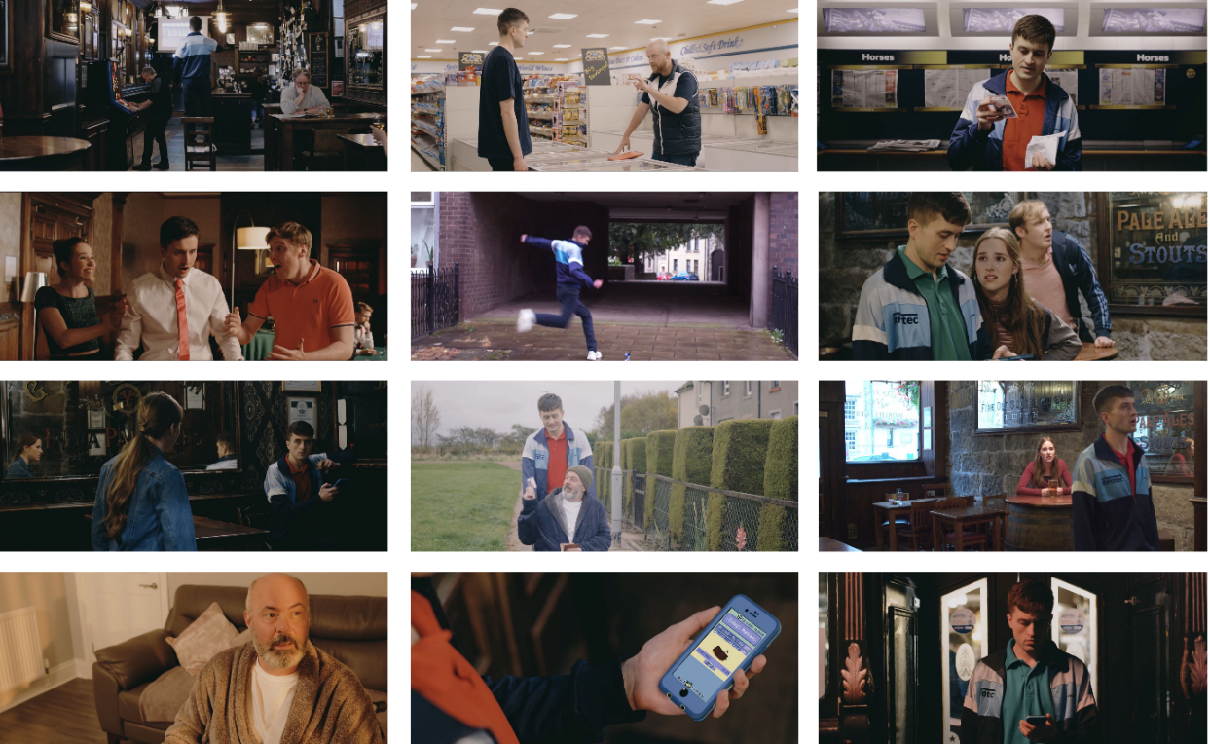
A synopsis of each scene is provided below:
1. The start/end of the film. Jack has taken money from his dad without his consent to bet on a horse race, hoping he will win back his and his friends’ holiday money.
2. Jack asks his boss for help getting a loan from his brother, a loan shark. Instead, his boss gives him a tip to bet on a horse race. In return, Jack will “owe him”.
3. Against all odds, Jack won his first bet on roulette at the casino.
4. Jack kicks a can on the floor and is reminded of how much he loved playing football and misses it.
5. Jack has entered a ‘bookies’ for the first time, about to gamble away all of his and his friends’ holiday money.
6. Becky finds Jack sitting alone in the corner of the pub, betting on his gambling app. He has lost a lot of money.
7. Jack bets on a football game using a gambling app for the first time. He wins, and is convinced he has the knack.
8. Jack’s dad has just asked Jack to buy him a lottery ticket, and is imagining the life he would lead if he was to win.
9. Jack’s dad gives Jack his credit card, after Jack asks him if he could borrow money for the deposit of a new flat. In truth, Jack is planning on using the money to gamble on a horse race.
10. Jack has bet on a horse race and is awaiting the outcome. Becky confronts Jack – she believes he has developed a problem with his gambling and should seek help.
11. After trying to control and cut down his gambling, Jack receives a pop-up notification on his phone with a free £5 credit towards a bet, drawing him back into gambling.
12. Jack has just gambled away his week’s wages in 3 hours by betting online.

Gambling behaviour ladder
15 minutes.
Learning outcomes: To consider the different levels of risk associated with gambling, and understand what constitutes harm.
Read out the scenarios. Then, in pairs or groups, ask pupils to rank each scenario from least to most risky. Ask each group to consider the frequency, stake size and motivation behind each character’s gambling. Afterwards, ask each group to share where they placed each scenario and why.
You may wish to print out the table below for each team, and cut out the scenarios individually.
Remember to emphasise that all gambling involves an element of risk; however, some gambling activities and behaviours may be riskier than others.
a) | Ryan wins £20 at the quiz machine, so he goes back with more money this time, hoping to win the Jackpot on the fruit machine.
b) | Jack stole money from his dad to bet on a horse race, hoping he will win back the money he stole from his friends.
c) | Becky’s gran puts £20 on the Grand National every year as a fun way of spending time with her family.
d) | Becky and Jack flip a coin to establish who has to mop the floor.
e) | Jack’s dad spends £2 a week on the lottery, even though he is struggling to pay his bills.

Support available
5 minutes.
Learning outcomes: To wind down the lesson by talking about the avenues of support that are available to someone experiencing gambling harm, as well as to those around him.
Ask the class to think of avenues of support that are available to someone who is experiencing gambling harm due to their own gambling or someone else’s gambling.
Examples include: speaking to a friend, parent, teacher, youth worker or trusted adult; visiting website for information (eg. BeGambleAware.org or BigDeal.org.uk); calling a helpline or using chat service; self-excluding yourself from betting shops; using blocking software for devices.
Make sure that pupils are aware of where they can access support if they are concerned about any of the issues that were explored in the lesson.
